
From the President’s Desk January 2026
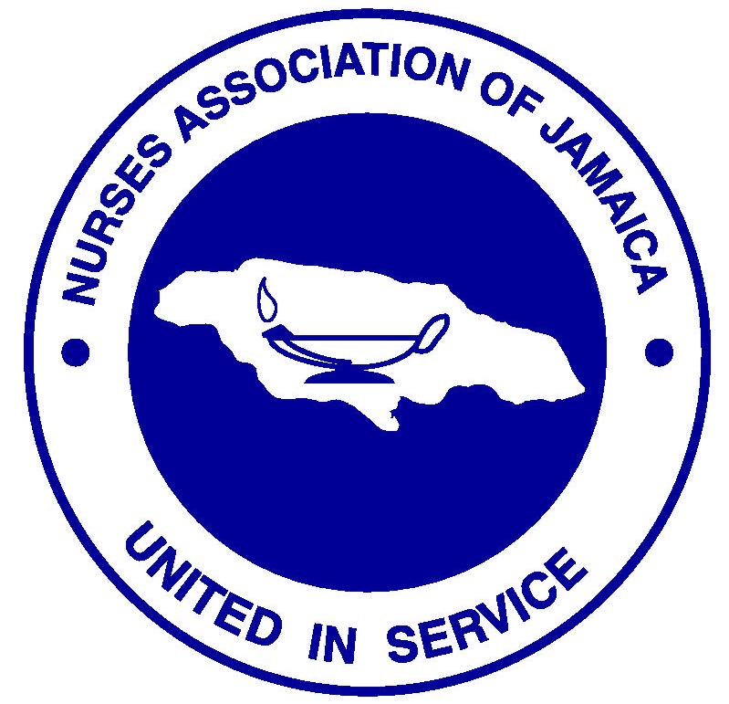

Happy New Year to you all!

I greet you warmly from the Secretariat. 2026 is here and I am sure that we are all grateful for the opportunity that has been awarded to us to numbered amongst those still here on earth. The Collins dictionary, in relation to the term newness, defines it as being ‘of a cycle; beginning or occurring again’. This is how we relate to a New Year; occurring again.
Let us always stay grounded to the truth that encourages us to carry on with renewed strength. The bible reminds us in Isaiah 43: 18 – 19, ‘Remember not the former things, nor consider the things of old. Behold, I am doing a new thing; now it springs forth, do you not perceive it? I will make a way in the wilderness and rivers in the dessert’. This is God’s promise to us. And He never reneges on promises.
I encourage you today to make your faith stand out. Be your best you. The struggles are real! I am aware. But as long as we remain motivated by life itself, we will find a way to make the bad good, the wrong right, and the peace be productive. Let us face our challenges head on and know that we can do anything our mind perceives.
I leave you with a message I found on social media: ‘by looking ahead, creating new choices, making Welcome 2026 decisions, acting with confidence, moving forward with determination, rediscovering enthusiasm, giving direction to your own life, and opening new paths’.
Blessings for a productive 2026, as we remain ‘United in Service’.

Save the Date!
- January 10, 2026 – 2nd Island Council Meeting
- March 7, 2026 – 2nd Quarterly General Meeting
- March 30, 2026 – NSOY Project
- April 24, 2026 – Annual Fish Fry
- May 12, 2026 – International Nurses Day
- May 10 – 16, 2026 – Membership Week
- June 2026 – 80th Anniversary Banquet

‘Newness can be uncertain and vulnerable, but it is a reminder you are still growing, still alive’. – Leah Zaccaria
United In Service.

Dawn-Marie Richards
January 2026

Did you Know?

.

Activities
- January 7 – Executive Meeting – Arnold Road
- January 10 – 2nd Island Council Meeting – Annotto Bay
- January 15 – Combined Committee Meeting
- January 17 – Funeral Service for mother of Denese Dacres Reeves
- January 28 – 80th Anniversary Launch – Venue TBA

For your Information

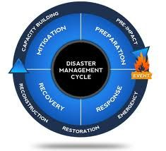
- Internet Search – January 5, 2026
A profession is, by definition, a group of people with special disciplinary knowledge and skills; with public expectation of adherence to standards and codes of behaviour; and who apply this knowledge, skills, ethics and behaviour in a practice which is in the interest of others. In common language, the word ‘nursing’ is used to describe both the profession and the practice. This professional practice is carried out through the work and lives of the members of the nursing profession, nurses.
DEFINITION OF ‘NURSING’
Nursing is a profession dedicated to upholding everyone’s right to enjoy the highest attainable standard of health, through a shared commitment to providing collaborative, culturally safe, people-centred care and services. Nursing acts and advocates for people’s equitable access to health and health care, and safe, sustainable environments.
The practice of nursing embodies the philosophy and values of the profession in providing professional care in the most personal health-related aspects of people’s lives. Nursing promotes health, protects safety and continuity in care, and manages and leads health care organizations and systems. Nursing’s practice is underpinned by a unique combination of science-based disciplinary knowledge, technical capability, ethical standards, and therapeutic relationships. Nursing is committed to compassion, social justice and a better future for humanity.

DISASTER MANAGEMENT
The disaster management cycle is a continuous process that includes
the phases of mitigation, preparedness, response, and recovery, aimed at reducing the impact of disasters and enhancing community resilience.

Continuous Nature of the Cycle
The disaster management cycle is not linear; rather, it is a continuous loop where each phase informs and strengthens the next. Lessons learned from past disasters are integrated into future planning, creating a robust framework for community safety and resilience. This cyclical approach ensures that disaster management evolves based on experiences and changing circumstances, ultimately leading to better preparedness and response capabilities.

