

**From the President’s Desk**

**Message for the Month October 2024**

**Greetings from the Secretariat**

As we move into the second of the “Ber” months, we realize that the year 2024 is closer to its end. Here in Jamaica, we celebrate our Heroes in this month. For those persons who are culture conscious, this month is significant. Persons become involved in the history of Jamaica, the things that used to be are put on display and the Jamaican culture is highlighted. I want to take this opportunity to remind us, using a popular quote “a people without knowledge of their past history, origin and culture is like a tree without its roots” - Marcus Garvey; one of our own seven (7) National Heroes. The others are Samuel Sharpe, Nanny of the Maroons, George William Gordon, Paul Bogle, Norman Washington Manley and Sir Alexander Bustamante. As we navigate the month of October, let us be mindful of our past, the sacrifices that have been made; the progress that we would have also made as a country and be reminded that we have come a long way. Our heroes paved the way for the modernization that we enjoy today. Be thankful as we celebrate National Heroes Day this month. We remain United in Service.

**Jamaica Coalition for Tobacco Control. (JCTC)**

This is an advocacy group of health organizations that support healthy lifestyles and the objectives of the World Health Organization Treaty – the Framework Convention on Tobacco Control, operating from the Heart Foundation of Jamaica. The JCTC works closely with Government, Non-Government and other health Organizations to encourage tobacco abstinence, and minimize tobacco use. The NAJ is a part of this advocacy group, having two (2) representatives on the Board. Some activities include being a watchdog for the use of tobacco, engaging in World Tobacco prevention activities, participating in Research activities, among other activities that relate to the empowering of individuals to understand the health harms of tobacco and nicotine. World “No Tobacco Day” is celebrated on May 31 each year. Let us play our part as we educate our nation on health and safety risks related to the use of Tobacco.

***United in Service***

***Dawn-Marie Richards***

***October 2024***

***Motivational Corner***

 ***Save the Date!***

* Oct 10-12 – NAJ AGM /IC – Moon Palace
* Oct 21 - National Heroes Day
* Oct. 20-26 - CNO Biennial Conference – Guyana
* Oct 26 – CNO Day
* Nov 23 - Mary Seacole Day
* December – Make a Child Smile Activities

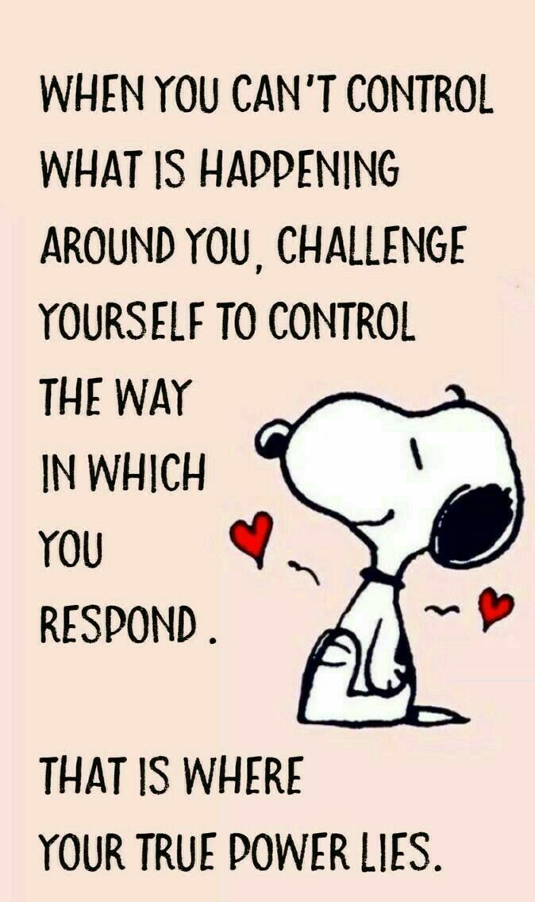

***Did you Know?***

***Bandana -*** A symbol of pride for Jamaicans who are heritage conscious. The fabric is used to make a full outfit and then worn as the Jamaican National Costume. It is plaid with the colours red, yellow and white and is popularly known as the unofficial national fabric. For some persons, it is synonymous with Louise Bennett Coverly “Miss Lou”, who made the fabric quite popular in her public appearances. It is worn by market vendors, singers and storytellers and is most popular during Jamaica’s ceremonial, cultural and independence holidays or when Jamaicans travel to other lands and are showcasing their culture. The fabric is available locally as well as outfits handmade by our local seamstresses. I will end by saying a Jamaican in bandana is showcasing the islands’ history and culture. It is not just fabric, it is a symbol of our heritage (Jamaica experiences).

***Activities***

* Oct 1 – Officers Meetings
* Oct 2 – Executive meeting
* Oct 10-12 – NAJ AGM/IC – Moon Palace
* Oct 20-26 – CNO Biennial Conference – Guyana
* Oct 26 – CNO Day